**Exercise**

package com.example.datetimepicker;  
  
import androidx.appcompat.app.AppCompatActivity;  
  
import android.app.DatePickerDialog;  
import android.app.TimePickerDialog;  
import android.os.Bundle;  
import android.view.View;  
import android.widget.Button;  
import android.widget.DatePicker;  
import android.widget.EditText;  
import android.widget.TimePicker;  
  
import java.util.Calendar;  
  
public class MainActivity extends AppCompatActivity {  
  
 Button changeTime, changeDate;  
 EditText timeET, dateEt;  
  
 @Override  
 protected void onCreate(Bundle savedInstanceState) {  
 super.onCreate(savedInstanceState);  
 setContentView(R.layout.*activity_main*);  
  
 changeTime = (Button) findViewById(R.id.*changetimebtn*);  
 changeDate = (Button) findViewById(R.id.*button2*);  
 changeTime.setOnClickListener(new View.OnClickListener() {  
 @Override  
 public void onClick(View v) {  
 timeET = (EditText) findViewById(R.id.*editTextTime*);  
 Calendar mcurrentTime = Calendar.*getInstance*();  
 int hour = mcurrentTime.get(Calendar.*HOUR_OF_DAY*);  
 int minute = mcurrentTime.get(Calendar.*MINUTE*);  
 TimePickerDialog mTimePicker;  
 mTimePicker = new TimePickerDialog(MainActivity.this, new TimePickerDialog.OnTimeSetListener() {  
 @Override  
 public void onTimeSet(TimePicker timePicker, int selectedHour, int selectedMinute) {  
 timeET.setText( selectedHour + ":" + selectedMinute);  
 }  
 }, hour, minute, true);//Yes 24 hour time  
 mTimePicker.setTitle("Select Time");  
 mTimePicker.show();  
  
 }  
 });  
  
 changeDate.setOnClickListener(new View.OnClickListener() {  
 @Override  
 public void onClick(View v){  
 dateEt = (EditText) findViewById(R.id.*editTextDate*);  
 Calendar c=Calendar.*getInstance*();  
 Integer month=c.get(Calendar.*MONTH*);  
 Integer day=c.get(Calendar.*DAY_OF_MONTH*);  
 Integer year=c.get(Calendar.*YEAR*);  
  
 DatePickerDialog datePickerDialog =new DatePickerDialog(MainActivity.this, new DatePickerDialog.OnDateSetListener() {  
 @Override  
 public void onDateSet(DatePicker view, int year, int month, int dayOfMonth) {  
 dateEt.setText(dayOfMonth+"/"+month+"/"+year);  
 }  
 },year,month,day);  
 datePickerDialog.show();  
 }  
 });  
 }  
}

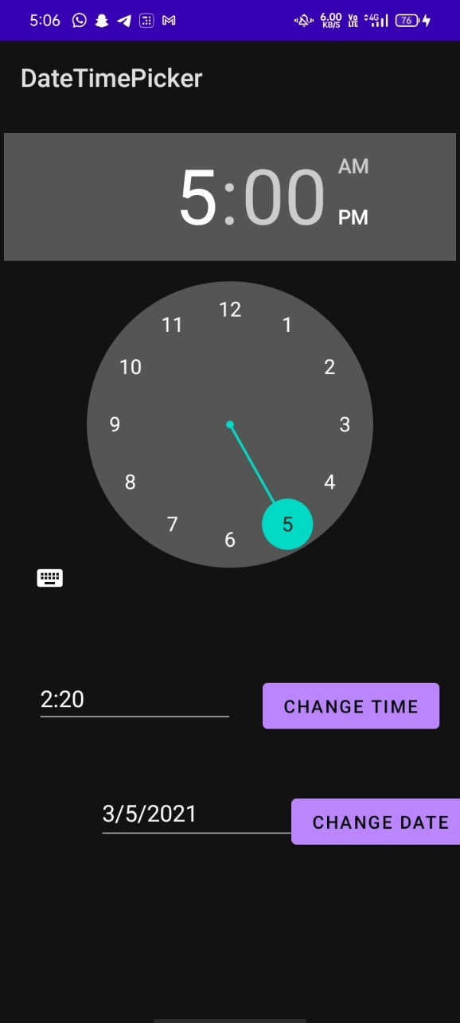

**Practical Related Questions**

1. **XML time picker tag with its attributes**

<TimePicker  
 android:id="@+id/timePicker1"  
 android:layout_width="354dp"  
 android:layout_height="356dp"  
 android:layout_marginTop="16dp"  
 app:layout_constraintEnd_toEndOf="parent"  
 app:layout_constraintHorizontal_bias="0.491"  
 app:layout_constraintStart_toStartOf="parent"  
 app:layout_constraintTop_toTopOf="parent" />

1. 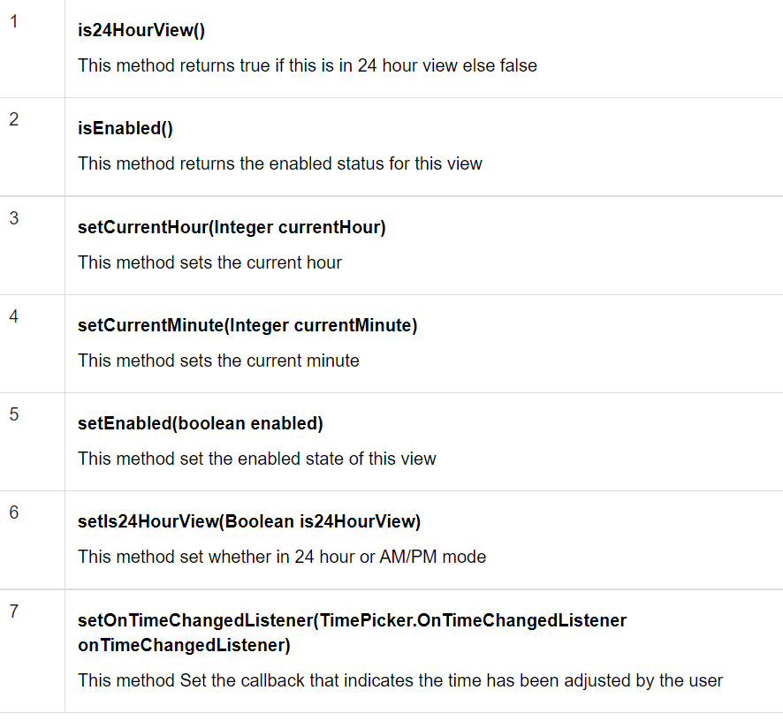**Write and explain methods of timepicker class**
2. **List and explain any 5 methods of Date Picker class**

